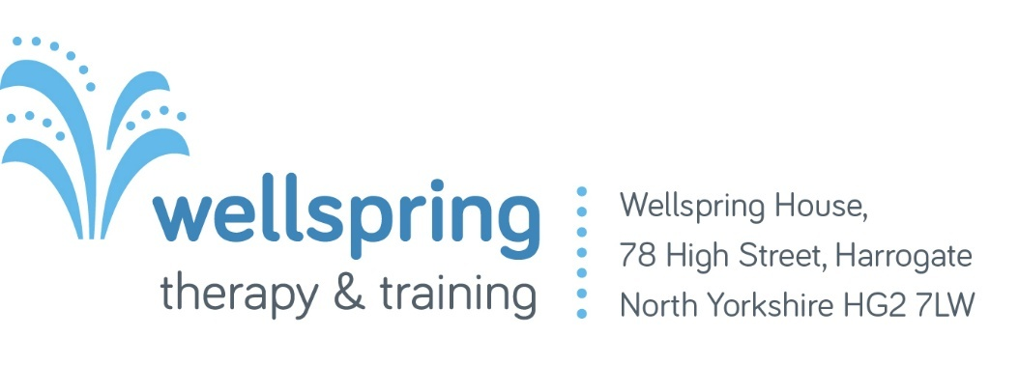

Job Description
Job title | Children and Young People’s Freelance Creative Therapist in Rural primary schools
Salary & Hours | £30p/h as a freelance contractor, plus travel allowance. The contract is for 10 hours per week, spread across two adjacent sites over two days.
Contract | One school term (January to April)
Responsible to | Clinical Lead
Location | Pateley Bridge schools
Benefits | Travel allowance, internal supervision, materials budget

Vision
Wellspring aims to restore hope, develop resilience and facilitate positive change.

Objectives
- Provide valuable insight into the provision of therapy in a rural setting helping Wellspring, the local authority and the NHS understand how to achieve health equity.
- Provide creative therapy in two primary schools
- Work collaboratively with the two schools and Wellspring to provide therapy

Values
- We are a welcoming community to all who are involved in our organisation.
- We are committed to practising professionalism.
- We endeavour to be ethical in all decision making and practice.
- The charity is motivated, in all its activities, by Christian faith and values.
- We foster a culture of generosity, to both our team and our clients.

Purpose of the role
To provide therapy to primary school age children in two adjacent schools in Pateley Bridge. To provide insight on how to meet the therapeutic needs of families in rural areas. To work in agreement with the charity’s beliefs, values, policies and procedures. To develop and provide output and outcome measures to help evaluate the project. The post holder must be sympathetic to the Christian ethos and vision of Wellspring.

Key Tasks

Creative Therapy delivery
- Liaise with school staff, such as the SENCO, to gather appropriate referrals, goals and outcomes.
- Conduct initial assessments with a child, and parents if required
- Offer 121 creative therapy sessions to children for one term.
- Work safely and ethically within Wellspring’s and the Schools Policies and procedures
- To communicate and liaise with other agencies, in the best interests of the young person, whilst maintaining the limits of confidentiality.
- Work with the organisations' designated safeguarding person(s) when appropriate and within the safeguarding policies and procedures.
- To be a member of the HCPC and adhere to their standards of proficiency.
- Maintain and develop professional practice through regular and ongoing personal development, internal clinical supervision and creative engagement.

Administration
- Maintain accurate records of therapy sessions and client information in line with GDPR.
- Use the organisations forms, databases and assessments to collect data about the project
- Be proficient in the use of outlook and basic IT skills.
- Be aware of best practice guidelines for the storage of artworks made during therapy, and ensure they are stored correctly.
Service Evaluation
- Support the Clinical Lead in designing and carrying out evaluation.
- Work collaboratively with Wellspring, the school and professions such as Educational Psychology on evaluating the project to see if it can be scaled.
- Advocate for Creative Therapy professions in Primary Education.
Personal specification
Freelance Creative Therapist

Criteria | Essential | Desirable
Qualifications  Masters qualification in Art/ Music/ Drama Therapy  Membership with The Health and Care Professions Council  Recent child protection/safeguarding training.  DBS at an enhanced Level  Experience working with primary age children | E  E  E  E | D
Skills/competencies  Ability to establish good relationships and communicate well with Children  Ability to provide one-to-one therapy sessions with children in a professional and ethical way.  Knowledge of schools, extended school services, children & family services, and other relevant agencies.  Knowledge of how to work positively and inclusively with parents and school pastoral staff while retaining confidentiality.  Knowledge of how to participate appropriately and ethically in multi-agency meetings.  Ability to provide guidance and consultation to school staff and other professionals on matters of children and families mental health and emotional wellbeing as requested.  Ability to establish and maintain effective communication with all key organisations and individuals.  Ability to implement and maintain systems for monitoring and evaluating work, including statistical analysis.  Ability to manage own workload and use initiative.  Ability to work well in a team and contribute to a whole school approach of good emotional health and wellbeing.  Willingness to work flexibly to meet the demands of the school service. | E  E  E  E  E  E  E  E  E  E | D
Experience  Experience of working with Children or families.  Experience in assessing child protection concerns and the ability to act on these in accordance with relevant safeguarding procedures.  Experience in carrying out mental health assessments including assessment of risk, analysis of strengths and protective factors.  Experience of working in school/education settings. | E | D  D  D
Personal qualities  Sympathetic to / sharing the Christian ethos and vision of Wellspring. | E

Application Form: Creative Therapist for a Pilot Project delivering Therapy in rural primary schools

The deadline for applications is 5pm on 09/11/2026

Please complete all sections of the application and continue on a separate sheet if you need more space. Please put your name on any additional sheets and if sending the application via post, fasten securely to this form. To facilitate equality of opportunity the front sheet (page 1) will not be used during the short-listing process.

Full name:

Full address:

Telephone:

Email:

REFERENCES
Please give the name, address, telephone number and email of two people who can provide references. Please also state their relationship to you, e.g. employer, college tutor. One should be your current or most recent employer or placement provider.

1 | 2

Employment and voluntary experience
Please give details of all paid employment, and relevant volunteering such as student placements with the most recent first.

Employer | Post Held & Description | From | To | Reason for leaving

EDUCATION & TRAINING
Please give details of all education and training you have undertaken or are currently participating in, including details of qualifications gained, with the most recent first.

Institution/ Awarding Body | Course/ Qualification | From | To

SUITABILITY
Please state why you are applying for this post and what you would bring to the role, making particular reference to the criteria set out in the person specification and job description supplied with this application form. Please continue on a separate sheet if you wish.

Health
REHABILITATION OF OFFENDERS ACT
Right to work

Do you have a legal right to work in the UK?

YES NO

Do you consider yourself to be disabled? Yes No

Does this prevent you from meeting any of the working arrangements or duties of this post?

Yes No

If yes, you are still encouraged to apply as we may be able to make some changes to the working arrangements of this post to accommodate the needs of a suitable disabled applicant.

If called for an interview do you require us to make any particular arrangements?

Yes No
If yes, please explain below:

Positions Exempt from Rehabilitation of Offenders Act

The work you are applying for affords you access to minors/vulnerable adults so it is exempt from the Rehabilitation of Offenders Act 1974. You must therefore provide details of any prosecutions or convictions, including final warnings, reprimands, cautions, bind-overs, supervision orders or care orders and any pending prosecutions which you may have, even if they would be regarded as “spent” under the Rehabilitation of Offenders Act 1974.

Have you any criminal convictions (spent or otherwise), final warnings, reprimands, cautions, bind-overs, supervision orders or secure orders and any pending prosecutions?

Yes No

As part of the appointment process, Wellspring will carry out a Disclosure and Barring Service check on the preferred candidate. This will provide the above information.
If you have answered YES to the above, please provide details of the offence, dates, sentence, fine or other penalty in the box below. Answering “YES” will not necessarily prevent you from being considered for this post. The information will be treated in confidence and will be destroyed if the application is unsuccessful. Deliberate failure to disclose full details is a criminal offence that will result in your application being rejected or may lead to your later dismissal.

Please provide details of any offences, dates, sentences, fines or other penalties:

I apply for the above post and confirm the information I have provided is accurate. I understand that the inclusion of false information or the omission of relevant information may lead to dismissal. I understand that an enhanced Disclosure and Barring Service check will be obtained on behalf of the successful candidate. I consent to Wellspring storing, processing and verifying my application details in accordance with the Data Protection Act 1988.

Signed: Date:

Thank you for taking the time to complete this application. Please return all forms to:

jobs@wellspringtherapy.co.uk or by post to Jude Crook, Wellspring Therapy, 78, High St Harrogate HG2 7LW

